Apress LightSwitch 2012 (Tim Leung) – Chapter 9

This source code includes an example that shows you how to make your application run faster by connecting to your Intrinsic database through a RIA service data source.
To run this example, you’ll need to ensure that database connection string for your RIA Service points to the correct file path. To do this, open the HelpDeskVB or HelpDeskCS project.
- Right click “EngineerData > Update Datasource”
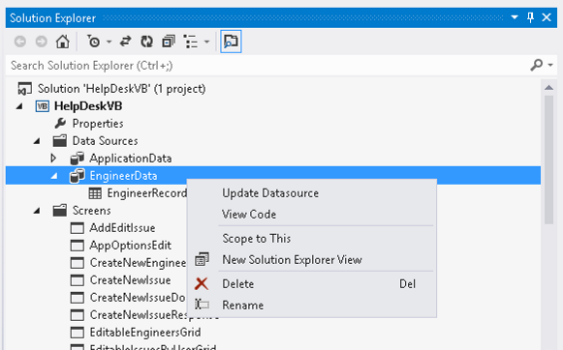
- Here’s the dialog that opens when you click the Update Datasource link.
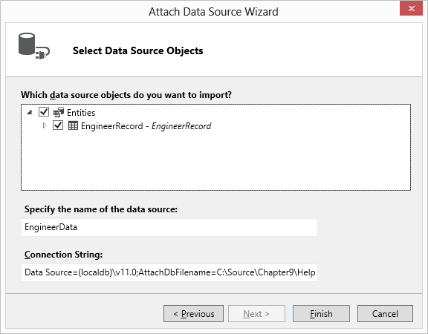
- Modify the value in the Connection String textbox so that it points to your Intrinsic (ApplicationDatabase.mdf) database file. The part that you should modify is highlighted below.
Data Source=(localdb)\v11.0;AttachDbFilename=C:\Source\Chapter9\HelpDeskVB\HelpDeskVB\bin\Data\ApplicationDatabase.mdf;Integrated Security=True
- Switch your solution to File View, go to the Server project, and click the button in Solution Explorer to ‘Show all Files’. Make sure that the reference to the HelpDeskDataService is valid. If not, you’ll need to re-add this reference.
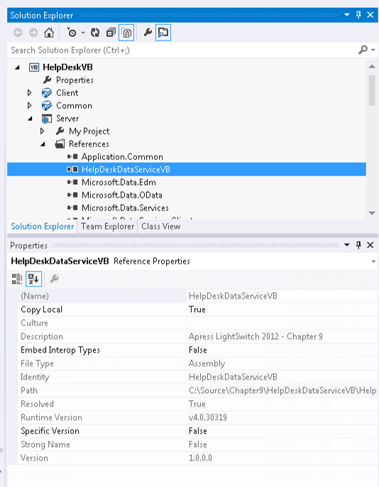

Once you’ve made these changes, your project should run. Note that if you extract the contents of the chapter 9 ZIP file into the folder C:\Source\Chapter9, you won’t need to make any of these modifications.
Tim Leung

